**Zomato Restaurant Analysis Report**

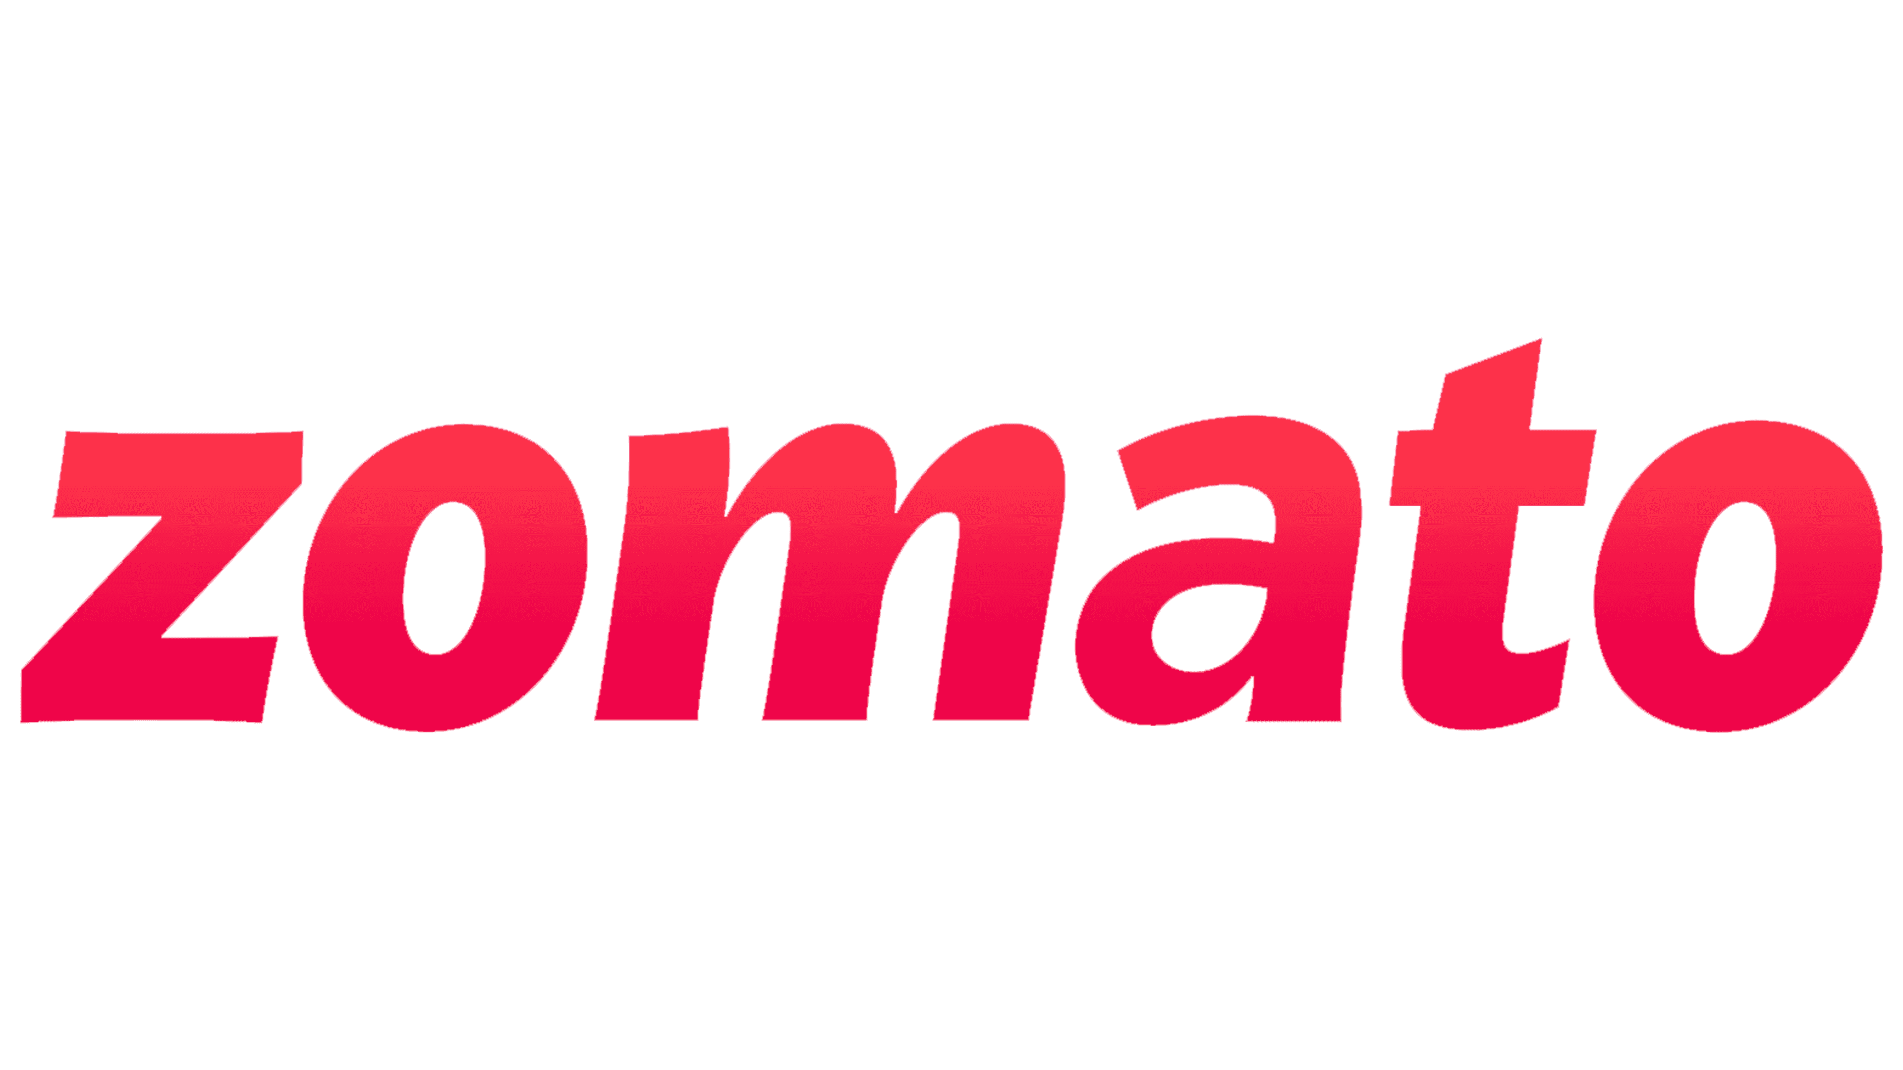

SU Wai

junior Business analyst

TripleTen

October 22, 2024

**Introduction:**

The objective of this report is to analyze restaurant performance, customer ratings, and trends over time. The analysis focuses on identifying key metrics such as total revenue, rating count popularity, and cuisine preferences to provide Zomato with actionable insights that will help improve operations, customer satisfaction, and revenue growth.

**Findings:**

1. ***160 Restaurants with a 5-Star Rating, but Sales and Revenue Leaders Differ:*** Although 160 restaurants have a 5-star rating, Maharaja Grills & Rolls leads in sales volume, while Domino’s Pizza generates the highest revenue, surpassing other restaurants by more than 3 million USD. Notably, neither of these two restaurants holds a 5-star rating, indicating that high revenue does not always correlate with top ratings.
2. ***Domino's Pizza Dominates in Revenue:*** Domino's Pizza stands out as the top performer in terms of total revenue, generating over 3 million USD more than its competitors. Its consistent high revenue suggests that Domino's is well-positioned to dominate the market.
3. ***Restaurant Popularity is Independent of Location:*** Restaurant popularity does not seem directly linked to geographic location. However, larger cities with higher population densities, such as Bangalore and Gurgaon, generate more total revenue. This indicates that urban areas are significant revenue drivers for Zomato.
4. ***Rating Quantity Does Not Correlate with Higher Ratings:*** The data shows that restaurants with a larger number of ratings (5,000–10,000 reviews) tend to have more consistent ratings, while those with 20–100 reviews display more variability. A higher quantity of reviews does not necessarily indicate better overall ratings.
5. ***North Indian Cuisine Dominates Sales:*** North Indian cuisine is the most popular in terms of both sales volume and customer preference, outperforming other cuisines like Chinese and Indian. This strong demand for North Indian cuisine presents a strategic opportunity for expansion.
6. ***Electronic City in Bangalore is the Most Popular Location:*** The Electronic City neighborhood in Bangalore emerges as the top location for restaurant orders. Other key areas, particularly in Bangalore and Gurgaon, are also major hubs for food delivery, making these cities critical for Zomato’s growth strategy.

**Graphs/Visuals:**

1. ***Rating Count Popularity:*** This graph shows the distribution of restaurant ratings and how the number of ratings impacts consistency. Restaurants with 5,000 to 10,000 ratings show more consistent averages**.**

1. ***Total Orders Over Time:*** This line chart shows the monthly fluctuation of total orders over the year. It highlights a decline in orders between April and July, followed by a sharp recovery peaking in October, suggesting seasonal trends in customer demand.

1. ***Cuisine Popularity:*** A tree map visualizing the popularity of various cuisines, with North Indian cuisine dominating in both sales volume and customer preferences.

**Conclusions:**

* The analysis demonstrates that while customer ratings are important, sales volume and revenue are not directly dependent on a restaurant's rating.
* Domino's Pizza dominates revenue despite not holding a top rating, while Maharaja Grills & Rolls leads in sales volume.
* Larger cities like Bangalore and Gurgaon drive higher revenues due to their population density. Additionally, North Indian cuisine shows an overwhelming preference, providing an opportunity for strategic growth.

These insights suggest that Zomato’s efforts to expand in densely populated urban areas and cater to customer preferences for certain cuisines can significantly boost performance.

**Recommendations:**

1. ***Expand Offerings of North Indian and Related Cuisines:*** Given the high demand for North Indian cuisine, Zomato should prioritize expanding restaurants offering North Indian, Chinese, and Indian cuisines, particularly in key cities like Bangalore and Gurgaon. This expansion could lead to a potential 10-15% increase in sales, capitalizing on existing customer preferences.
2. ***Domino’s Pizza Expansion:*** Domino’s Pizza has consistently shown high revenue generation. Expanding its outlets in metropolitan areas, especially in larger cities, can lead to an estimated 15-20% growth in revenue. Supporting Domino’s further growth will continue to drive significant revenue for Zomato.
3. ***Encourage More Customer Ratings for All Restaurants:*** Restaurants should actively encourage customers to leave more reviews, as a larger number of ratings tend to stabilize overall ratings and provide a clearer reflection of customer satisfaction. Implementing review incentives, such as offering discounts or loyalty rewards for reviews, could increase review participation, leading to greater transparency and helping customers make more informed dining choices.

**Business Implications:**

The findings and recommendations align with Zomato’s strategic goals of expanding market share, enhancing customer engagement, and optimizing revenue generation. By focusing on high-performing cuisines and expanding successful restaurant chains like Domino’s Pizza, Zomato can strengthen its position in key urban markets such as Bangalore and Gurgaon.

Furthermore, encouraging more customer reviews will not only improve transparency but also foster trust in Zomato’s platform, ultimately leading to increased customer retention and loyalty. By strategically expanding in regions with high demand and promoting high-performing cuisines, Zomato can achieve its broader objectives of boosting revenue and improving customer satisfaction.

**Strategic Alignment Summary:**

* Revenue Optimization: Expanding Domino's Pizza and North Indian cuisine offerings aligns directly with Zomato’s goal to maximize revenue in high-demand areas.
* Customer Satisfaction: Encouraging more customer reviews improves rating stability and increases trust, enhancing customer satisfaction.
* Market Expansion: Targeting cities like Bangalore and Gurgaon ensures Zomato focuses on high-revenue-generating regions, supporting its market expansion goals.